Javascript is not object oriented. It is object based language.

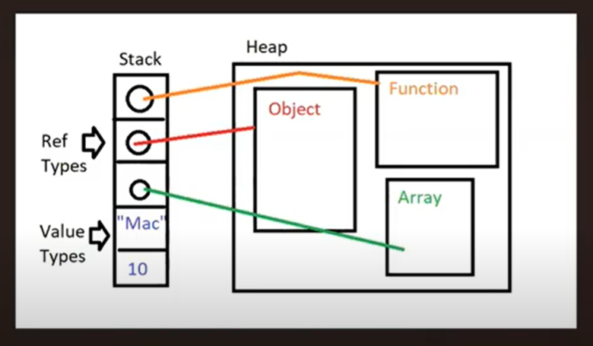

In Javascript, functions are spatial type of objects which is not the case in other languages like Java, C++. Dynamic allocation of memory for ref types.

VISUALIZATION OF OBJECTS:

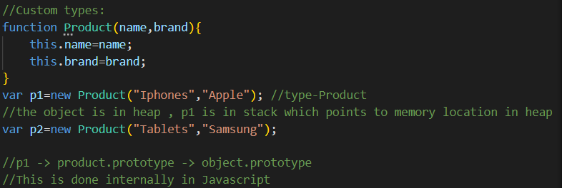

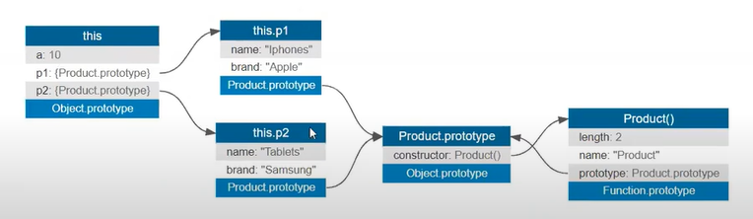

//objectplayground.com

Javascript has prototypial inheritance whereas OOP has classical inheritance.

Prototypial inheritance is Runtime inheritance whereas OOP can implement inheritance only at design time

Browser

JS engine

UI rendering engine

Browser API (NodeJS API)

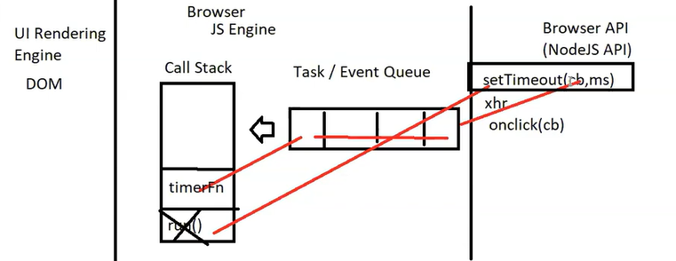

EVENT LOOP

